**Slider Application - Documentation**

|  |  |  |
| --- | --- | --- |
| Author Name | Date | Version |
| Vishnu Priya V | 11/9/2021 | 1.0 |

Table of Contents

Objective 3

Requirement 3

Implementation 3

Design 3

Desktop 3

Mobile & Tablet 4

Testing - Jasmine 4

Links 4

# Objective

To create a slider of 10 random images by requesting <https://picsum.photos/list>.

The list api returns a json array with information about images & their author. Use the “id” field to request a specific image at a specific size.

An example of this is: <https://picsum.photos/400/600?image=0> . This url requests image of id 0 at size 400x600.

# Requirement

1. All images should be size 200 x 300.
2. Above every image in the slider there should be the author’s name.
3. On page refresh it should load different random images

# Implementation

|  |  |
| --- | --- |
| Hardware Platform | Windows 10 |
| Software Platform | Visual Studio Code |
| Scripting Language | JavaScript, CSS, JQuery |
| Testing | Jasmine |

## Design

### Desktop

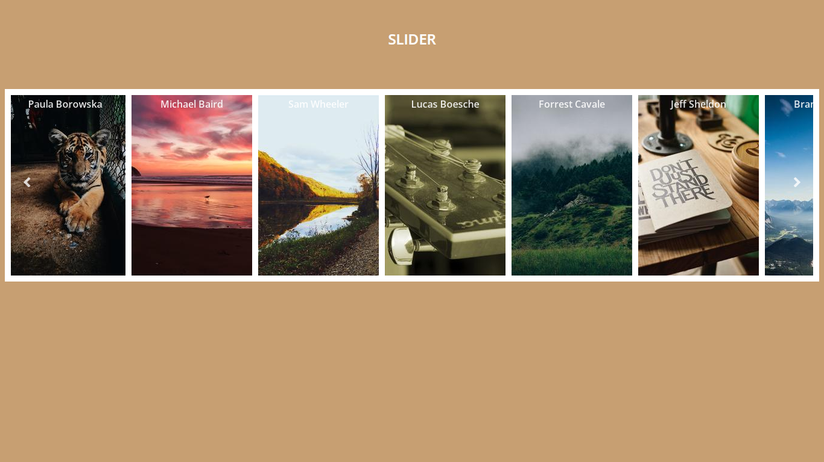

Screenshot – 1 – Desktop UI

### Mobile & Tablet

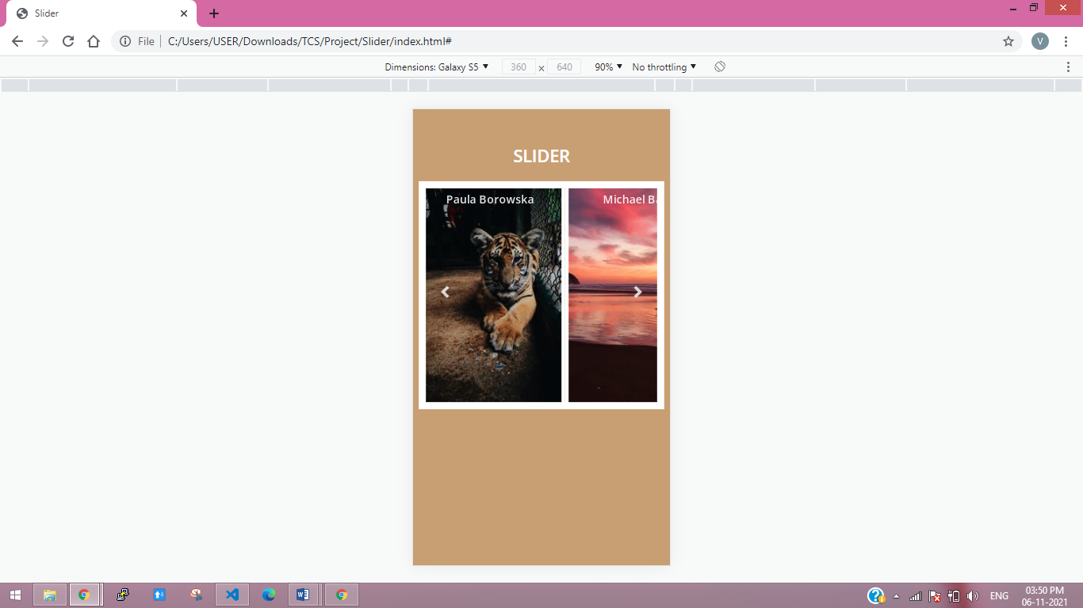 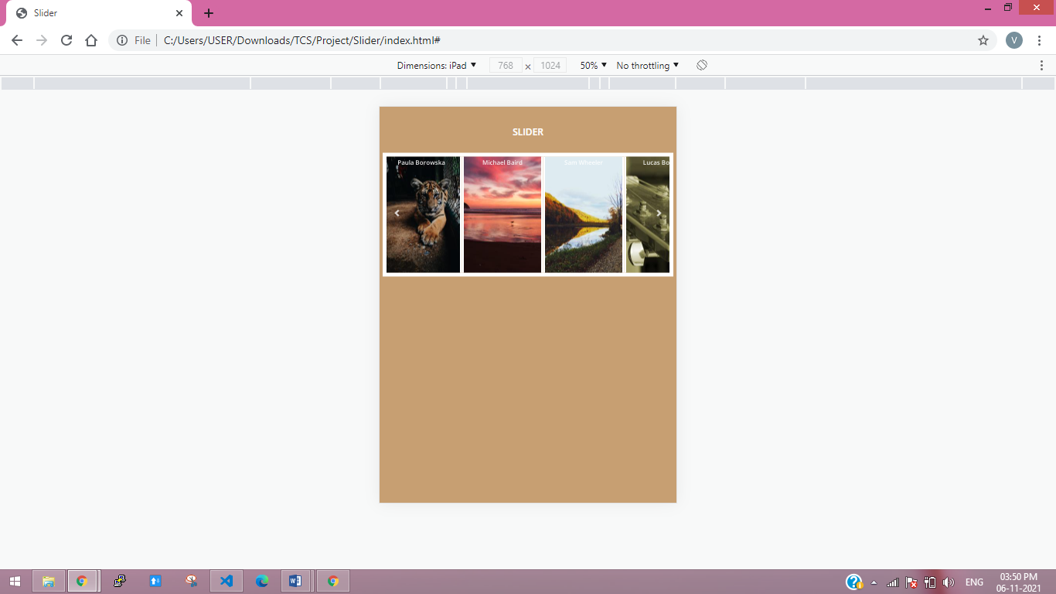

Screenshot – 2 – Mobile UI

Screenshot – 3 – Tablet UI

# Testing - Jasmine

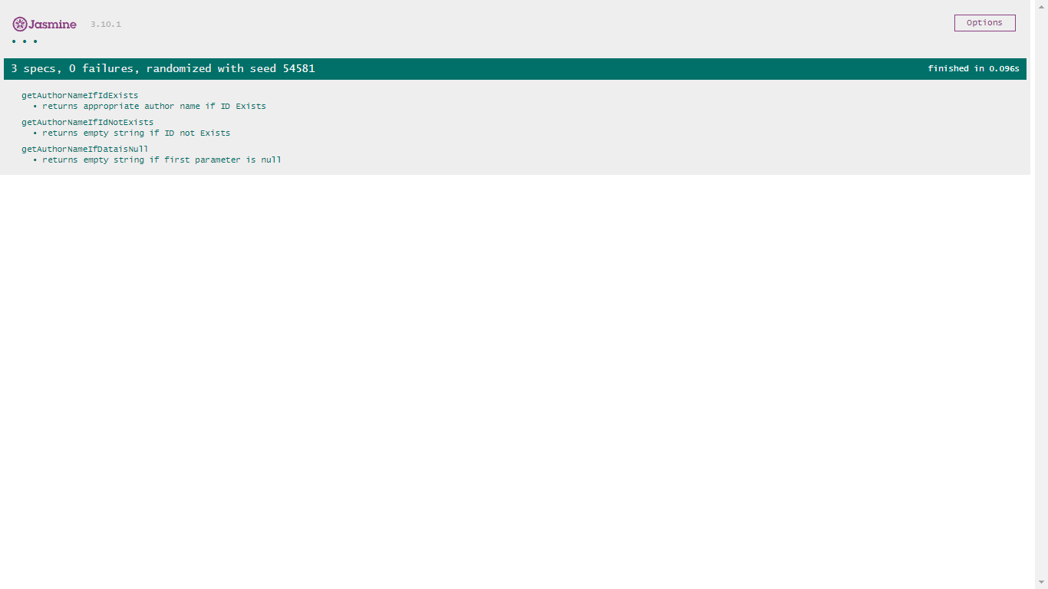

# Links

Query from - <http://ajax.googleapis.com/ajax/libs/jquery/3.6.0/jquery.min.js>

Free Font Awesome icons from - <https://cdnjs.cloudflare.com/ajax/libs/font-awesome/4.7.0/css/font-awesome.min.css>

Standalone Jasmine 3.10.1 from - <https://github.com/jasmine/jasmine/releases>